**Physics 30 Lessons 1 to 33 Review**

**Momentum**

1. What is the difference between an elastic and an inelastic collision?
2. Two identical automobiles have the same speed, one travelling east and one travelling west. Do these cars have the same momentum? Explain.
3. If two different objects have the same momentum, do they necessarily have the same kinetic energy? Give a reason for your answer.
4. Can a single object have kinetic energy but no momentum? Can a system of two or more objects have a total kinetic energy that is not zero but a total momentum that is zero? Account for your answers.
5. What is the impulse-momentum theorem? When driving a golf ball, a good "follow-through" helps to increase the distance of the drive. A good follow-through means that the club is kept in contact with the ball as long as possible. Using the impulse-momentum theorem, explain why this technique allows you to hit the ball farther .
6. A collision occurs between three moving billiard balls such that no net external force acts on the three-ball system. Is the momentum of each ball conserved during the collision? If so, explain why. If not, what quantity is conserved?
7. On a distant asteroid, a large catapult is used to "throw" large chunks of stone into space. Could such a device be used as a propulsion system to move the asteroid closer to the Earth? Explain.
8. Two men pushing a stalled car generate a net force of +840 N for 5.0 s. What is the final momentum of the car? (4.2 × 103 kg m/s)
9. A woman, driving a golf ball off the tee, gives the ball a speed of 28 m/s*.* The mass of the ball is 0.045 kg, and the duration of the impact with the golf club is 6.0 × 10-3 s. (a) What is the change in momentum of the ball? (b) Determine the average force applied by the club. (1.3 kg m/s, 2.1 × 103 N)
10. A 55 kg swimmer is standing on a stationary 210 kg floating raft. The swimmer then runs off the raft horizontally with a velocity of +4.6 m/s relative to the shore. Find the recoil velocity that the raft would have if there were no friction and resistance due to the water . (-1.2 m/s)
11. An astronaut is motionless in outer space. Upon command, the propulsion unit strapped to his back ejects some gas with a velocity of +14 m/s, and the astronaut recoils with a velocity of -0.50 m/s. After the gas is ejected, the mass of the astronaut is 160 kg. What is the mass of the ejected gas? (5.7 kg)
12. In a football game, a receiver is standing still, having just caught a pass. Before he can move, a tackler, running at a velocity of +4.5 m/s, grabs him. The tackler holds onto the receiver, and the two move off together with a velocity of +2.6 m/s. The mass of the tackler is 115 kg. Find the mass of the receiver. (84 kg)
13. A 0.0150 kg projectile is fired with a velocity of +715 m/s at a 2.00 kg wooden block that rests on a frictionless table. The velocity of the block, immediately after the projectile passes through it, is +40.0 m/s. Find the velocity with which the projectile exits from the block. (–4.62 × 103 m/s)
14. A volleyball is spiked so that its incoming velocity of +4.0 m/s is changed to an outgoing velocity of -21 m/s. The mass of the volleyball is 0.35 kg. What impulse does the player apply to the ball? (-8.8 N s)
15. A 1550 kg car, travelling with a velocity of +12.0 m/s, plows into a 1220 kg stationary car. During the collision, the two cars lock bumpers and then move together as a unit. (a) What is their common velocity just after impact? (b) What fraction of the initial kinetic energy remains after the collision? (6.71 m/s, 0.559)
16. A 2.50 g bullet, travelling at a velocity of +425 m/s, strikes the wooden block of a ballistic pendulum. The block has a mass of 0.200 kg. (a) Find the velocity of the bullet/block combination immediately after the collision. (b) How high does the combination rise above its initial position? (5.25 m/s, 1.4 m)

h

V

1. In the previous problem, the same type of bullet is used with the same type of block to find the speed of the bullet. The bullet/block combination rises 0.200 m above the block's rest position. What is the speed of the bullet? (160 m/s)
2. Write the conservation of energy equation for the following. Substitute the appropriate equations.

a) a car of mass m and initial speed v1 rolling to the bottom of a hill of height h, neglecting friction.

b) a charge q with mass m with initial speed v moving through a potential difference V

c) a photon of wavelength  hitting a stationary electron, scattering the photon at ' and giving the electron speed v.

d) for the photoelectric effect.

e) for x-ray production.

f) for photon emission by atoms.

1. A 0.050 kg bullet is fired from a 5.0 kg gun. If the velocity of the bullet is 275 m/s, what is the recoil velocity of the gun? (2.75 m/s)
2. A 4.0 kg object moving with unknown velocity collides with a 6.1 kg stationary object. After the collision, the 4.0 kg object travels with a velocity of 2.8 m/s 32.0˚ N of E and the 6.1 kg object travels with a velocity of 1.5 m/s 41.0˚ S of E. What was the velocity of the 4.0 kg object before the collision? (4.1 m/s @ 0.21˚ S of E)
3. A force-time graph for a 0.75 kg object that accelerated from rest is shown below. Calculate the velocity of the object at 4.0 s. (16 m/s)

1

2

4

3

1

4

2

5

6

3

Force (N)

Time (s)

**Light**

1. What factors influence the symmetrical interference pattern when a wave passes through two slits?
2. Draw and label a refraction diagram for a wave slowing down.
3. Draw and label a refraction diagram for a wave undergoing total internal reflection.
4. What are the two main theories regarding the nature of light?
5. A pin hole camera that is 16.0 cm long produces a 7.5 cm tall image of a 5.6 m tall object. What is the distance of the pinhole camera to the object? (11.9 m)
6. A 3 cm card is placed 25 cm in front of a light source. If a 30 cm shadow is generated on the wall behind the card, how far is the card from the wall? (225 cm)
7. Galaxy XX is located 6.5 × 10 22 km from Earth. How many light-years away is the ga1axy? (6.87 billion light years)
8. If the rotating mirror in Michelson's mirror experiment rotates at 83.3 Hz, how far away must the fixed mirror be located in order to give a successful experiment? (225 km)
9. If the fixed mirror in an eight-sided Michelson's mirror experiment is placed 65 km away from the rotating mirror, what is the frequency for the rotating mirror in order to give a successful experiment? (288 Hz)
10. What is the complete Snell's Law formula?
11. When does total internal reflection of light occur?
12. What is the index of refraction for a liquid in which the speed of light is 1.85 × 108 m/s? (1.62)
13. A ray of light strikes glass (n=1.5) with an incident angle of 50°. What is the refracted angle in the glass? (31°)
14. A prism bends the light such that an incident angle of 54° in air becomes a refracted angle of 30° in the glass. What is the speed of light in the glass? (1.85 × 108 m/s)
15. A substance has a critical angle of 39° for light travelling from it into air. What is the index of refraction for the substance? (1.59)
16. Light travels from diamond into air. If the angle of incidence is 30°, what is the angle of refraction? (TIR)
17. What experiment provided definitive evidence that light is a wave?
18. Monochromatic light strikes a diffraction grating of 0.25 mm spacing. The light passes through the grating to produce an interference pattern on a screen 3 m away. If 50 bright lines are produced over a 30 cm space, what is the wavelength and frequency of the light? (500 nm, 6 × 1014 Hz)
19. Red light of wavelength 644 nm strikes a double slit apparatus with a separation of 1.0 mm. If the bright bands have a 0.54 mm width, what is the distance from the double silt apparatus to the screen? (0.64 m)
20. Green light of 530 nm strikes a double silt apparatus with a separation of 1.5 mm. If the screen is located 2.5 m behind the double slit apparatus, how many bright lines per 20 cm could be generated on the screen? (226)
21. How many lines per metre does a diffraction grating have of the 2nd order image occurs at an angle of 16° when light of 530 nm wavelength is used? (3.47 × 105)
22. Monochromatic light with a frequency of 5.50 × 1014 Hz is directed onto a diffraction grating ruled with 6000 lines/m. What is the distance between the third bright line and the fifth dark line of the interference pattern formed on a screen 2.50 m from the grating? (0.0123 m)
23. A 6 cm object is located 25 cm in front of a diverging mirror with a radius of curvature equal to 40 cm. What is the size of the image? ( + 2.67 cm )
24. A 30 cm object is located 16 cm in front of a converging mirror with a focal length of 12 cm. What is the size of the image? ( -90 cm )
25. A 12 cm object located in front of a curved mirror generates an erect image 36 cm tall located 60 cm from the mirror. What is the radius of curvature for the mirror? What type of mirror is it? (60 cm, concave, converging )
26. An object located in front of a diverging mirror with a radius of curvature equal to 20 cm generates an erect image that is 1/5 the size of the object. What is the object distance? (40 cm)
27. A 4 cm tall object is located 10 cm in front of a concave lens with a focal length of 5 cm. What is the size of the image produced? ( 1.33 cm )
28. A 3 cm tall object is located 15 cm in front of a convex lens with a focal length of 5 cm. What is the size of the image produced? ( -1.5 cm )
29. A 6 cm object located 15 cm in front of an optical device generates an image 2 cm tall which located on the same side as the object. What is the focal length of the device? What is the type of device? ( -7.5 cm, concave lens )
30. A lens with a focal length of 4 cm generates an inverted image which is 5 times as large as the object. What is the image distance? ( 24 cm )
31. A lens with a focal length of 15 cm generates an erect image that is 1/4 the size of the object. What is the image distance? ( -11.25 cm )
32. Ultraviolet light has a wavelength of 11.0 nm in air. What is its wavelength of the ultraviolet light in glass with an index of refraction of 1.52? (7.24 nm)
33. A microwave travels 100 m through water. In the same time it took the microwave to travel this distance through water (n = 1.33), how far could it have travelled through air?

(133 m)

1. A 3 cm tall object is placed 10 cm in front of a concave mirror that has a radius of curvature of 6 cm. Mathematically determine the characteristics of the image. (Image is inverted and real, di = 4.3 cm and hi = -1.3 cm)
2. A 4.0 cm tall object is placed 9.0 cm from a concave lens. If the lens has a focal length of 5.0 cm, mathematically determine the characteristics of the image. (Image is erect and virtual, di = -3.2 cm and hi = 1.4 cm)
3. A diffraction grating has 5.00 × 105 lines/m. How many orders of maxima can be observed if the grating is illuminated with monochromatic light of wavelength of 580nm? (3)
4. Michelson’s eight-sided mirror and his fixed mirror are 30.0 km apart. What is the minimum velocity in revolutions per second that the eight-sided mirror would have to rotate in order that light would be reflected to the observer? (625 rev/s)

**Electricity**

1. In each of the following situations, you will need to draw diagrams showing how charges move between and through conducting materials. In every case, illustrate the Law of Conservation of Charge.

a) Using diagrams, explain the attraction of a neutral pith ball by a negatively charged rod by induced charge separation.

b) Using diagrams, explain how the leaves of an electroscope can become positively charged by induced charge separation.

c) Using diagrams, explain how an electroscope can be charged positively by conduction.

d) Using diagrams, explain how an electroscope can be charged positively by induction.

1. What is the difference between a conductor and an insulator?
2. What is Coulomb's Law?
3. What is the difference between an induced charge and an induced charge separation?
4. In 1795, a French scientist named ___________________ used a torsion balance to study the electric forces between two charged conducting spheres.
   1. What relationship did he discover between electric force and the distance between charged spheres?
   2. What is the relationship between the charged spheres and the product of their charges?
5. What are the two electric field strength equations? What is the difference between the charge q in the equations? What is the definition of the direction of the electric field at a point?
6. Draw the electric field lines

a) around a positive charge

b) around a negative charge

c) between a positive and a negative charge

d) between two oppositely charged parallel plates

1. Draw a graph showing electric field strength as a function of distance

a) around a point charge

b) from the positive plate between two parallel plates

1. Write the balanced force equation for a mass m with charge q suspended in between two parallel plates separated by distance d, having potential difference V between them. Solve for d.
2. In a region of space where the electric field is constant everywhere, as it is in a parallel plate system, is the potential constant everywhere? Account for your answer.
3. A proton and electron are released from rest at the midpoint between the plates of a charged parallel plate capacitor. Except for these particles, nothing else is between the plates. Which particle strikes a capacitor plate first? Why?
4. What is current? What are the base SI units for current?
5. What is the difference between conventional current and electron flow current?
6. A charge of 1.2 mC is fixed at each corner of a rectangle that is 30 cm wide and 40 cm long. What is the magnitude and direction of the electric force on each charge? What is the electric field at the centre? (2.1 × 105 N, 0)
7. Show that the unit V/m is equivalent to N/C. What quantity are these the units of?
8. Equally charged spheres A, B and C are lying on a straight line. If the distance between spheres A and B is 1.5 cm, and the distance between spheres B and C s 4.5 cm, how does the force that sphere C exerts on sphere B compare with the force that sphere A exerts on sphere B?
9. Two small spheres have the same mass and volume. One of the spheres has a charge of -3.00 μC and the other sphere has a charge of -1.50 μC. If these two spheres are brought into brief contact with each other and then separated to a distance of 50 cm, what is the electrostatic force between them? (1.82 × 10-1 N)
10. If the electric field strength at a point 1.50 m from a charged point source is 2.70 × 104 N/C, what is the electric field strength at a point 75 cm from a charged point source? (1.08 × 105 N/C)
11. Two small spheres, each with a mass of 2.00 × 10-5 kg are placed 0.350 m apart. One sphere has a charge of -2.00 μC and is fixed in position. The other sphere has a charge of -3.00 μC and is free to move. What is the initial acceleration of the second sphere? (2.2 × 104 m/s2)
12. Two small charges, +40 μC and -18 μC are placed 24 cm apart. What is the net force on a third small charge of -2.5 μC if it is placed on the line joining the other two and 12 cm outside of the negative charge? (21 N away from negative charge)
13. An alpha particle is placed between two horizontal, parallel charged plates that are 2.0 cm apart. The potential difference between the plates is 12.0 V.
    1. What is the electric force acting on the alpha particle? (1.92 × 10-16 N)
    2. What is the gravitational force acting on the alpha particle? (6.52 × 10-26 N)
    3. Assuming that the electric force and the gravitational force are acting on opposite directions, what is the acceleration of the alpha particle? (2.89 × 1010 m/s2)
    4. What potential difference would be required between the plates in order for the alpha particle to become suspended? (4.08 × 10-9 V)
14. An alpha particle is placed in an electric field with a potential difference of 80 V. If the alpha particle is released within the field, what is the maximum speed that the alpha particle could attain? (8.77 × 104 m/s)
15. An alpha particle with an initial speed of 7.15 × 104 m/s enters through a hole in the positive plate to enter the space between two vertical parallel plates that are 0.090 m apart. If the electric field between the two plates is 170 N/C, what is the speed of the alpha particle when it reaches the negative plate? (8.11 × 104 m/s)

#### Magnetic Fields, Magnetic Forces, and EMR

1. What are the Laws of Magnetic Poles?
2. Draw magnetic field lines for the following, indicating the direction of the field on the field lines.

N

N

N

S

S

N

S

S

Earth

1. Draw field lines for the following:

e-

•

1. What will happen in the following cases? (attract or repel)

×

•

•

•

I

N

e-

I

1. What will happen to the charge or wire in the following cases?

I

N

S

•

N

S

e-

−

X X X X X X X X

X X X X X X X X

X X X X X X X X

X X X X X X X X

B

•

•

•

•

•

•

•

•

•

•

•

•

•

•

•

•

•

•

•

•

•

•

•

•

•

•

•

•

•

•

+

B

1. Write the force equation for a moving charged particle (q) of mass m in a magnetic field B. Solve for R.
2. Express the unit Tesla in terms of Newtons, seconds, metres, and Coulombs.
3. Express the unit Tesla in terms of Newtons, metres, and Amperes.
4. What is Faraday's law of Electromagnetic Induction?
5. What is Lenz's Law?
6. Explain the difference in the way a motor and a generator work.
7. What is the difference between motors and generators?
8. Calculate the magnitude and direction of the magnetic force on an electron travelling west with a velocity of 3.52 × 105 m/s through a magnetic field of 0.280 T directed out of the page. (1.58 × 10-14 south (down))
9. Calculate the magnitude and direction of the magnetic force on an alpha particle travelling upward at a speed of 2.11 × 105 m/s through a magnetic field of 200 mT directed down?
10. A potential difference of 1.70 kV accelerates an electron from rest. The electron then enters perpendicularly into a magnetic field of 250 mT. What is the magnitude of the magnetic force acting on the electron? (9.77 × 10-13 N)
11. A 0.75 cm long conductor carries a conventional current of 2.0 A vertically downward through a magnetic field of 2.7 mT directed south. What is the magnitude and direction of the magnetic force acting on the conductor? (4.1 × 10-5 N west)
12. A wire is placed over a compass needle and conventional current flows from A to B as shown in the diagram. What direction will the compass needle point?

B

A

current

1. In the diagram below, a 5.0 cm wire experiences a force of 0.023 N directed out of the page in a 1.25 T magnetic field. What is the magnitude and direction of the current in the conductor? (0.37A to the right)

S

N

1. Determine which end of the wire will become negatively charged.

B

A

N S

1. A potential difference of 16.6 kV accelerated a singly charged ion from rest. This ion then entered a magnetic field of 32.0 mT perpendicular to the direction of the ion’s motion. If the magnetic force on the ion was 5.27 × 10-15 N, what was the mass of the ion? (5.01 × 10-27 kg)
2. Doubly charged ions with a mass of 4.00 × 10-26 kg pass undeflected through the velocity selector of a mass spectrometer. This velocity selector has a magnetic field of 0.820 T and an electric field of 4.00 × 105 V/m perpendicular to one another. These ions then enter into the ion separation region. If the radius of the deflected ions is 5.0cm, what is the strength of the magnetic field in this region? (1.22 T)

**Nature of the Atom**

1. What are J.J. Thomson's contributions to the study of matter?
2. Write the balanced force equation for a charged particle moving through Thomson's cathode ray tube in which both the magnetic and electric fields are turned on. Solve for v.
3. Write the balanced force equation for a charged particle moving through Thomson's cathode ray tube in which only the magnetic field is turned on. Solve for the charge to mass ratio.
4. Which scientist used the results of Thomson's q/m ratio to ultimately calculate the mass on the electron? What experiment did this scientist perform?
5. Approximately 5.0% of the electric energy supplied to an incandescent light bulb converts into light energy. How many photons are emitted each second by a 40.0W light bulb if the average wavelength of the photons is 550 nm? (5.5 × 1018 photons)
6. Light with a wavelength of 5.30 × 10-7 m illuminates a photoelectric surface that has a work function of 1.70 eV. What is the maximum energy of the emitted electrons? (1.03 × 10-19 J)
7. Electrons are ejected from a photoelectric surface with a maximum speed of 4.20 × 105 m/s. If the work function of this surface is 2.55 eV, what is the wavelength of the incident light? (407 nm)
8. Radiation with a frequency of 7.52 × 1014 Hz illuminates a photoelectric surface in a photoelectric cell. If the work function of this surface is 2.20 eV, what stopping voltage would be required to reduce the current through this cell to zero? (0.913 V)
9. Calculate the momentum of a 6.0 MeV proton. (5.7 × 10-20 kg⋅m/s)
10. An incident x-ray causes an electron, which was initially at rest, to have a speed of

3.7 × 108 m/s. The scattered x-ray has a frequency of 1.41 × 1017 Hz. What is the

wavelength and momentum of the incident x-ray? (3.19 × 10-12 m , 2.08 × 10-22kg m/s)

1. Calculate the charge-to-mass ratio of a particle travelling 3.60 × 105 m/s that is deflected in an arc with a radius of 7.40 cm as it travels through a perpendicular magnetic field of 610 mT. (7.98 × 106 C/kg)
2. A proton travels through a 0.75 T magnetic field in a circle with a radius of 0.30 m. What is the momentum of this proton? (3.6 × 10-20 kg m/s)
3. An ion with a charge-to-mass ratio of 1.10 × 104 C/kg travels perpendicular to a magnetic field of 910 mT in a circular path with radius of 0.240 m. How long does it take the ion to travel one revolution? (6.28 × 10-4 s)
4. X2+ and Y+ ions, whose masses are 8.35 × 10-27 kg and 3.34 × 10-27 kg respectively, travelling at the same speed enter a magnetic field. If the X2+ ions are deflected through an arc with a radius of 0.400 m, what is the radius of the arc through which the Y+ ions are deflected? (0.320 m)
5. In an experiment similar to Millikan's oil drop experiment, an oil drop having a weight of 2.40 × 10-15 N is falling at a constant speed of 3.60 m/s between two horizontal parallel charged plates. If the potential difference between the two plates is 1.00 × 102 V and the plates are 6.00 cm apart, what is the magnitude of the charge on the oil drop? (1.44 × 10-18 C)
6. In an experiment similar to Millikan's oil drop experiment, an oil drop that has a mass of 3.60 × 10-16 kg is accelerated upward at a rate of 1.60 m/s2 between two horizontal parallel plates. If the electric field between the plates is 5.13 × 103 V/m, what is the magnitude of the charge on the oil drop? (8.00 × 10-19 C)
7. What is Planck's quantum hypothesis?
8. A Frank-Hertz experiment was carried out with on Fritzogen vapour in a chamber. The energies of the electrons sent into the chamber (Einput) and those coming out of the chamber (Eouput) were measured and the data is given below.

Einput (eV) Eoutput (eV)

3.0 3.0

4.0 4.0

5.5 0.0

6.0 0.5

7.0 0.0 or 1.5

7.5 0.5 or 2.0

8.0 1.0 or 2.5

9.0 0.0 or 2.0 or 3.5

a) Draw an energy level diagram for Fritzogen.

b) What wavelengths of light would you expect Fritzogen to absorb?

c) What wavelengths of light would you expect Fritzogen to emit?

1. How many photons are emitted per second by a 2.0 W helium-neon laser ( = 633 nm)? (6.4 × 108 photons/s)
2. How did Einstein explain the photoelectric effect?
3. Explain the relationship between

a) work function and threshold frequency

b) kinetic energy of photoelectrons and intensity of incident light

c) kinetic energy of photoelectrons and frequency of incident light

d) photocurrent and intensity of incident light

e) photocurrent and frequency of incident light

1. Plot a graph of kinetic energy vs. frequency for 2 metals. On the graph, indicate the threshold frequency, work function, and how Planck's constant is measured.
2. If an electron is emitted from a photoelectric surface of a photoelectric cell with kinetic energy of 11.0 eV, what is the stopping voltage of this electron? (11.0 V)
3. Monochromatic light falls on a photoelectric surface that has a work function of 1.00 eV. If the voltage required to stop the ejected electron is 2.10 × 10-1 V, what is the wavelength of the incident radiation? (589 nm)
4. A photoelectric surface is illuminated with monochromatic light with a wavelength of 625 nm. What is the maximum speed of electron ejected from this surface if the surface has a work function of 1.40 eV? (4.55 × 105 m/s)
5. A cathode ray tube is operating with a potential difference of 3.20 × 105 V. What is the shortest wavelength of radiation produced in this tube? (3.88 × 10-12 m)
6. What is the maximum wavelength of light that will cause electrons to be emitted from a photoelectric surface that has a work function of 3.2 eV? (388 nm)
7. The shortest wavelength of the EMR produced in a cathode ray tube is 7.20 × 10-10 m. What is the operating potential difference of this tube? (1.73 kV)
8. Electrons with a speed of 1.00 x107 m/s strike the target of an X-ray tube. What is the operating potential difference of this tube? (285 V)
9. Cathode rays with a speed of 8.50 × 106 m/s strike the target of an X-ray tube. What is the minimum wavelength of the EMR produced? (6.04 nm)
10. A student directed a laser beam through a diffraction grating ruled 2.20 × 105 lines/m and obtained an interference pattern on a screen 75.0 cm from the grating. If the 1st order maximum was 7.00 cm from the central maximum, what is the energy of each photon in the beam? (4.69 × 10-19 J)
11. If electrons with a momentum of 1.40 × 10-23 kg⋅m/s collide with a metal target, what is the maximum frequency of the X-rays produced? (1.62 × 1017 Hz)
12. What is the maximum kinetic energy of the electrons ejected from a photoelectric surface if the threshold frequency of the metal is fo and the frequency of the EMR falling on this surface is 2.6 x fo. (1.6hfo)
13. Electrons are ejected from a photoelectric surface with a maximum speed of 7.8 × 105 m/s. If the work function of this surface of this surface is 3.7 eV, what is the wavelength of the incident EMR? (229 nm)
14. What is the Compton effect? What is the significance of the results of Compton's experiments?
15. What is the significance of deBroglie's work?
16. Calculate the frequency of a photon if its momentum is 7.60 × 10-29 kg m/s. (3.44 × 1013 Hz)
17. What is the frequency of the wave of an electron that is moving at a speed of 5.60 × 107 m/s?( 4.31 × 1018 Hz)
18. Find the momentum of a photon that has a frequency of 9.10 × 1018 Hz. (2.01 × 10-23 kg m/s)
19. Calculate the velocity of an electron if it has a wavelength of 4.22 × 10-11 m. (1.72 × 107 m/s)
20. Find the momentum of a photon that has an energy of 7.00 eV.
21. Calculate the momentum of a 0.75 eV electron.
22. Assuming the atom was initially at rest, find the recoil speed of a hydrogen atom when it emits a 486 nm photon.. (0.817 m/s)
23. A radioactive nucleus, Cobalt-60, emits a gamma ray of wavelength 2.7 × 10-13 m. Assuming the nucleus was initially at rest, what is its recoil velocity upon emitting this photon? (2.45 × 104 m/s)
24. An electron that has 6.30 eV of kinetic energy collides with element V. The energy of this electron after collision is 3.05 eV. What is one possible energy transition of this element? (3.25 eV)
25. An electron and a photon both have a kinetic energy of 2.30 eV. (a) How does the speed of the electron compare with the speed of the photon? (b) How does the momentum of the electron compare with the momentum of the photon?
26. An electron with kinetic energy of 19.6 eV bombards atom X. After the collision, this electron has 17.2 eV. What is one wavelength of light that would be emitted by an excited gaseous X atom? (518 nm)
27. An atom can absorb energies of 5.3 eV, 7.2 eV, and 9.6 eV. If an electron with kinetic energy of 10.2 eV is used to bombard this atom, what is the range of possible energies of this electron after the collision? (4.9 eV, 3.0 eV, 0.6 eV)
28. An electron that has 5.50 eV of kinetic energy collides with element V. The energy of this electron after the collision is 2.66 eV. What is one possible energy transition of this element? (2.84 eV)
29. An atom of element M can emit photons of energies 3.40 × 10-18 J, 1.75 × 10-18 J, and 9.33 × 10-18 J. If an electron with kinetic energy of 8.70 × 10-19 J is used to bombard an unexcited atom of this element, what is the energy of this electron after the collision? (8.70 × 10-19 J)
30. The spectra lines of element X have wavelength s of 409 nm, 562 nm, 589 nm, and 673 nm. If an unexcited atom of element X is bombarded with an electron with 2.19 eV of kinetic energy, what is the energy of this electron after collision? (0.08 eV)
31. What was the significance of the Franck-Hertz experiment?
32. What was the significance of Bohr's model of the atom?
33. Why was Rutherford important?
34. One of the spectra lines of an unknown element has a wavelength of 523 nm. Calculate the energy of the electron transition that is involved. (2.38 eV)

**Old diploma exam questions**

1. A single stationary railway car is bumped by a five‑car train moving at 9.3 km/h. The six cars move off together after the collision. Assuming that the masses of all the railway cars are the same, then the speed of the new six‑car train immediately after impact is

A. 7.8 km/h

B. 8.5 km/h

C. 9.3 km/h

D. 11 km/h

Numerical Response

1. A horizontal force of 207 N acts on a 7.80 kg bowling ball for 0.520 s. The change in the ball's speed is __________ m/s.

(Record your **three-digit answer** in the numerical-response section on the answer sheet.)

1. Light passing from glass (n = 1.5) into water (n =1.3) will

A. increase in both speed and wavelength

B. decrease in both speed and wavelength

C. increase in speed but decrease in wavelength

D. decrease in speed but increase in wavelength

*Use the following information to answer the next question.*

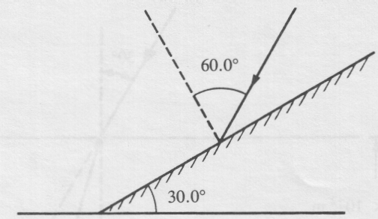

A plane mirror is positioned such that its surface makes an angle of 30° to the horizontal. A ray of light strikes the mirror at an angle of incidence of 60°.

1. The angle between the reflected ray and the horizontal is

A. 0°

B. 30°

C. 60°

D. 90°

1. A 20 cm object located 40 cm from a convex lens produces an inverted image that is 100 cm tall. If the object is moved to a distance of 80 cm from the lens, what is the size of the image produced?

A. –20 cm

B. –14 cm

C. +14 cm

D. +20 cm

Numerical Response

1. Light passing through a double slit of separation 3.0 × 10-5 m produces a first-order maximum 3.0 cm from the central maximum on a screen 1.5 m away. The frequency of the light, expressed in scientific notation, is ***a*.*b*** × 10***cd*** Hz. The values of ***a***, ***b***, ***c*** and ***d*** are ___, ___, ___, and ___.

(Record your **four-digit** answer in the numerical‑response section on the answer sheet.)

*Use the following information to answer the next question*.

**Movement of Charges**

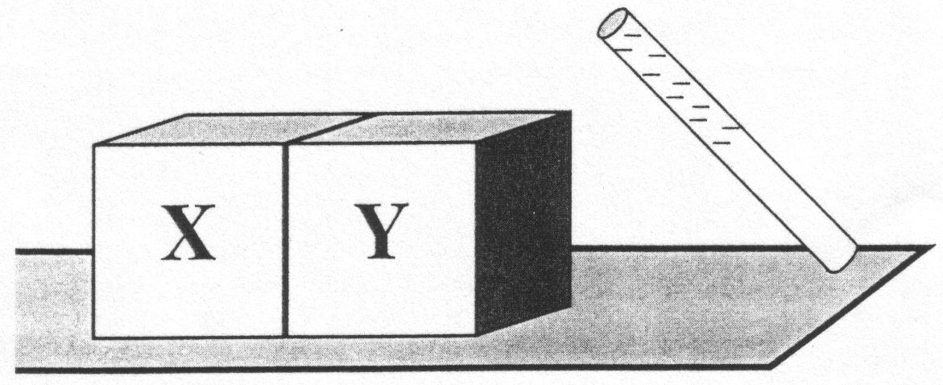

Two neutral metal objects (X and Y) are placed on a wooden table in contact with each other. A negatively charged rod is brought near object Y, and while the rod is nearby, the metal objects are separated without grounding.

1. Which statement correctly describes what has occurred after the charged rod was removed?

A. Object X received a negative charge by conduction, and object Y received a positive charge by conduction.

B. Object X received a negative charge by induction, and object Y received a positive charge by induction

C. Objects X and Y both received a negative charge by induction

D. Objects X and Y both received a negative charge by conduction

1. Two positive charges, q1 of 2.0 × 10‑6 C and q2 of 3.0 × 10‑6 C, are separated by 3.0 m. The electric force between them is

A. 2.0 x 10‑3 N (repulsion)

B. 2.0 x 10‑3 N (attraction)

C. 6.0 x 10‑3 N (repulsion)

D. 6.0 x 10‑3 N (attraction)

*Use the following information to answer the next question.*

Two point charges of equal magnitude, +*Q* and –*Q*, are each placed at an equal distance, *x*, from point ***P***, as shown below.

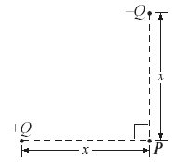

1. The direction of the resultant electric field at point *P* is

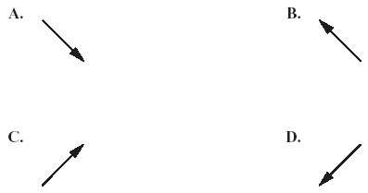

1. A particle with a charge of 3.0 × 10‑12 C moves with a speed of 2.0 × 102 m/s at right angles to a magnetic field. The strength of the magnetic field is 0.400 T. The magnitude of the force acting on the particle due to the field is

A. 4.8 × 10-8 N

B. 2.4 × 10-10 N

C. 1.5 × 10-13 N

D. 1.3 × 10-17 N

*Use the following information to answer the next question.*

**Electron Beam in a Magnetic Field**

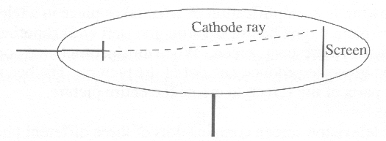

electron beam

An external magnetic field is directed out of the page.

1. A magnetic field directed out of the page caused the electron beam to move up the screen. What arrangement of electric plates would cause them to return to the centre?

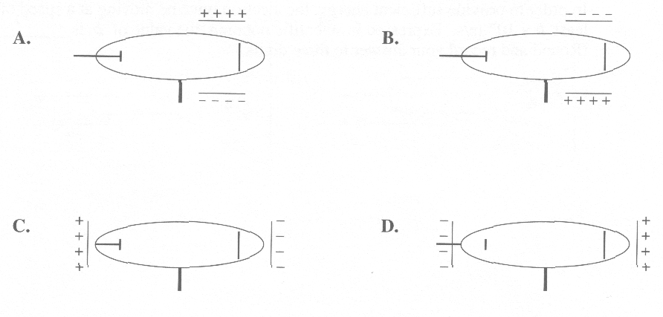

1. Which of the following phenomena produces a continuous spectrum?

A. Light emitted by a hot solid

B. Light emitted by a hot, low-density gas

C. Light emitted by a cool gas and then passed through a hot, low-density gas

D. Light emitted by a hot solid and then passed through a cool, low-density gas

*Use the following information to answer the next question.*

A student made the following statements with respect to infrared rays, microwaves, and ultraviolet light.

I. They all exhibit diffraction.

II. They all exhibit interference.

III. They all have the same frequency in a vacuum.

IV. They all have a speed of 3.00 × 108 m/s in a vacuum.

1. The statement made by the student that is **incorrect** is

A. I

B. II

C. III

D. IV

*Use the following information to answer the next question*.

One example of Compton scattering is shown below. The incident photon has a momentum of 1.83 × 10-23 N·s. It collides with a free electron that is initially at rest. The scattered photon has a momentum of 1.72 × 10-23 s N·s, 85.0° from the direction of the incident photon.

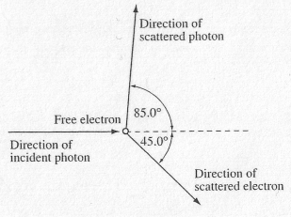

1. The magnitude of the momentum of the free electron after it has been hit by the incident photon is

A. 1.10 × 10-23 kg·m/s

B. 1.68 × 10-23 kg·m/s

C. 1.71 × 10-23 kg·m/s

D. 2.40 × 10-23 kg·m/s

________________________

*Use the following information to answer the next question*.

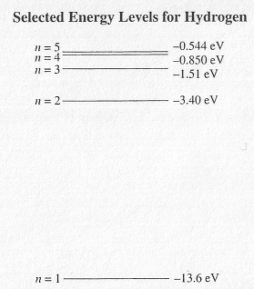

1. A free electron that has a kinetic energy of 2.0 eV collides with an excited hydrogen atom in which the electron is in the n = 2 energy level. As a result of this collision, the electron in the hydrogen atom is in energy level

A. *n* = 2

B. *n* = 3

C. *n* = 4

D. *n* = 5

__________________________

1. Together, the Compton effect and the de Broglie hypothesis support the concept of

A. wave-particle duality

B. the wave nature of matter

C. the particle nature of light

D. the particle nature of matter

*Use the following information to answer the next four questions*.

**Coulomb Explosion**

A Coulomb explosion occurs when a high-energy complex ion is brought to rest in a collision with a solid object. In one such collision, a helium-hydrogen ion, HeH+, collides with a carbon foil target. During this collision, all of the electrons are stripped from the incident helium-hydrogen ion. The ion splits into an alpha particle, 2+, and a proton, p+.

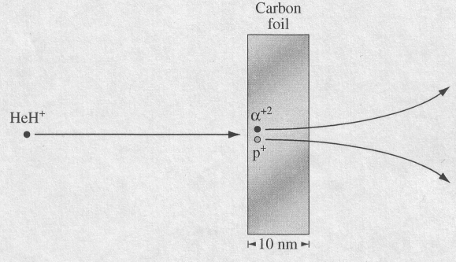

**Properties of a Helium-Hydrogen Ion (HeH+)**

Kinetic energy before collision 3.00 MeV

Length of helium-hydrogen bond 8.00 × 10-11 m

Mass 8.32 × 10-27 kg

**Energies of Scattered Particles**

Alpha particle 2.20 MeV

Proton 0.600 MeV

Electrons and electromagnetic radiation are also detected.

1. The minimum electric potential difference required to accelerate the helium-hydrogen ions from rest is

A. 3.00 eV

B. 3.00 MeV

C. 3.00 MV

D. 3.00 MJ

1. The conservation principle that is necessary to predict the number of electrons that should be produced when one helium hydrogen ion (HeH+) turns into an alpha particle and a proton is the conservation of

A. mass

B. charge

C. energy

D. momentum

1. The electrostatic force of repulsion of the alpha particle and the proton on each other immediately after the collision is

A. 3.60 × 10-8 N

B. 7.19 × 10-8 N

C. 2.88 × 10-18 N

D. 5.75 × 10-18 N

1. As the alpha particle and proton move apart the electrostatic force varies

A. directly with the distance between the particles.

B. inversely with the distance between the particles.

C. directly as the square of the distance between the particles.

D. inversely as the square of the distance between the particles.

______________________________

*Use the following information to answer the next question*.

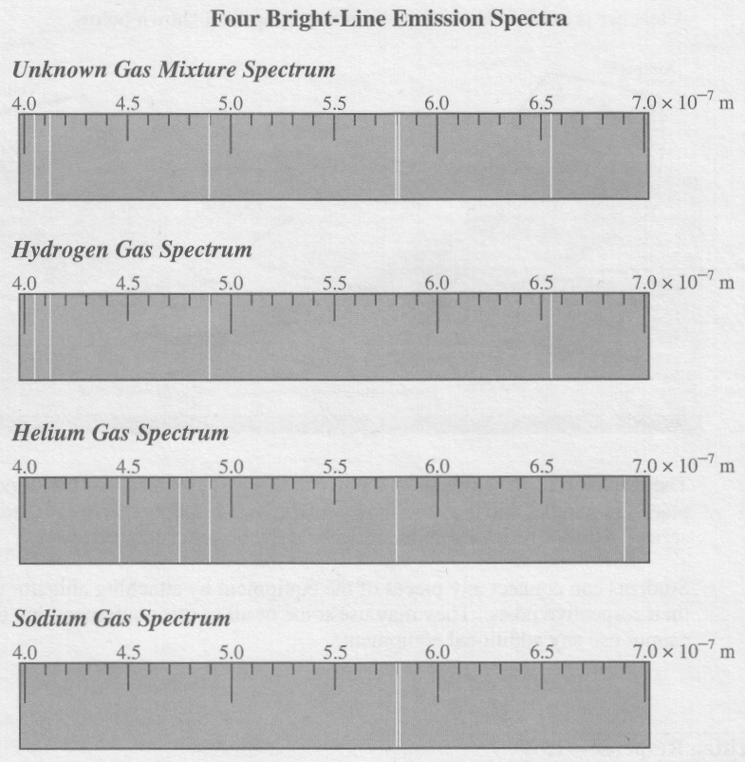

1. According to the spectra above, the unknown gas mixture contains

A. hydrogen, helium, and sodium gases

B. hydrogen and sodium gases

C. hydrogen and helium gases

D. helium and sodium gases

______________________________

*Use the following information to answer the next four questions.*

Physicists have produced "optical cooling" by shining a laser onto glass that contains ytterbium ions (Yb3+). The glass with ytterbium ions absorbs the laser photons and radiates photons with a shorter wavelength, as shown below. This process decreases the temperature of the glass with ytterbium ions.

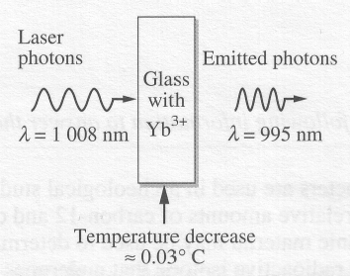

One theory suggests that the cooling occurs because of electron movement between energy levels in the ytterbium ions, as shown below. If a ground state electron in an ytterbium ion absorbs a small amount of thermal energy, it moves to the second energy level (n = 2). The ion then absorbs the laser photon, which moves the electron to the excited state (n = 3). The cooling occurs when the ytterbium ion emits a photon.

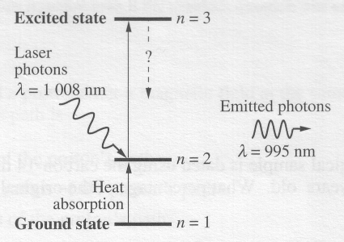

1. When the glass cools, the ions lose both the thermal energy and the energy that was absorbed from the laser photons. The electron energy level transition that occurs is from energy level

A. *n* = 3 to *n* = 2

B. *n* = 3 to *n* = 1

C. *n* = 2 to *n* = 1

D. *n* = 2 to *n* = 3

Numerical Response

1. The frequency of the laser photons, expressed in scientific notation, is **a.b** × 10**cd** Hz. The values of **a**, **b**, **c**, and **d** are ____, ____, ____ and ____ .

(Record your **four-digit answer** in the numerical-response section on the answer sheet.)

1. The energy difference between a laser photon and an emitted photon is

A. 2.00 × 10-19 J

B. 1.97 × 10-19 J

C. 2.58 × 10-21 J

D. 8.62 × 10-33 J

1. Visible light has frequencies that range between 4.3 × 1014 Hz (red) and 7.5 × 1014 Hz (violet). Which of the following statements best describes the absorbed laser photon and the emitted photon in the optical cooling experiment?

A. Both photons are in the infrared range.

B. Both photons are in the ultraviolet range.

C. Both photons are in the visible light range.

D. One photon is in the visible light range, and one is not in the visible light range.

__________________________________

*Use the following information to answer the next four questions.*

A student follows three procedures to study the properties of laser light. She uses a laser that emits monochromatic light that has a wavelength of 634 nm.

|  |  |  |
| --- | --- | --- |
|  | **Procedure** | **Observation** |
| **I** | The student first shines the laser light through a crystal that has an index of refraction of 1.53. | The path of the refracted ray is recorded. |
| **II** | The student shines the laser light through a diffraction grating that has 5.00 × 105 lines/m. | An interference pattern is projected onto a screen. |
| **III** | The student shines the laser light upon a photovoltaic cell that is connected to an ammeter. | No electrical current is measured. |

1. The energy of one photon emitted by the laser is

A. 4.20 × 10–40 J

B. 4.20 × 10–31 J

C. 3.14 × 10–28 J

D. 3.14 × 10–19 J

1. *In procedure I, the wavelength of the laser light in the crystal is __* ***i__****. The speed of the laser light in the crystal is __* ***ii__*** *than its speed in air.*

The statements above are completed by the information in row

|  |  |  |
| --- | --- | --- |
| **Row** | ***i*** | ***ii*** |
| A. | 4.14 × 10–7 m | less |
| B. | 4.14 × 10–7 m | greater |
| C. | 9.70 × 10–7 m | less |
| D. | 9.70 × 10–7 m | greater |

Numerical Response

1. In procedure II, the angle between the central maximum and the first bright spot of the interference pattern is __________.

(Record your **three-digit answer** in the numerical-response section on the answer sheet.)

1. *In order to produce an electrical current in procedure III, the student must use electromagnetic radiation that has a ___****i___*** *wavelength or a photovoltaic plate that has a ____****ii___*** *work function than those she actually used in procedure III.*

The statements above are completed by the information in row

|  |  |  |
| --- | --- | --- |
| **Row** | ***i*** | ***ii*** |
| A. | shorter | larger |
| B. | longer | larger |
| C. | shorter | smaller |
| D. | longer | smaller |

_________________________________

1. Which of the following lists has selected regions of the electromagnetic spectrum arranged in order of increasing photon energy?

A. Radio, microwaves, X-rays, visible

B. Infrared, ultraviolet, X-rays, gamma

C. Gamma, visible, infrared, microwaves

D. Microwaves, ultraviolet, visible, infrared

*Use the following information to answer the next four questions.*

Following the introduction of quantum theory in the early 1900s, the centuries‑old arguments concerning the wave or particle nature of light and other electromagnetic radiation were reinvestigated. The diagrams below depict experiments performed to demonstrate the particle properties of electromagnetic waves.

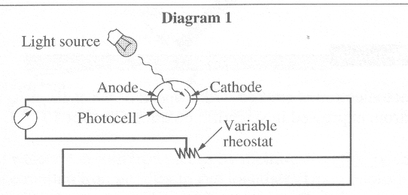

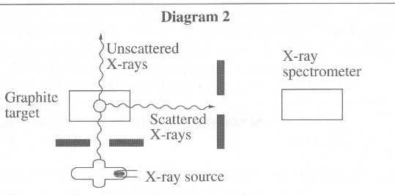

1. The two experiments depicted successfully proved that EM wave photons are similar to particles in that they both have

A. wavelength and momentum

B. energy and momentum

C. energy and wavelength

D. energy and frequency

1. The experiments depicted in the diagrams were used to prove theories concerning particle properties of EM waves described by

A. Einstein and Compton

B. Einstein and de Broglie

C. Einstein and Rutherford

D. Compton and de Broglie

1. Louis de Broglie proposed a hypothesis that was related to which of the following statements?

A. The energy absorbed by an atom is the same as the energy released by the atom.

B. If light has particle properties, then particles may have wave properties.

C. The intensity of light controls the current in the photoelectric effect.

D. Energy and mass are related.

Numerical Response

1. If the photoelectron is emitted with a speed of 6.8 × 105 m/s, the kinetic energy of the electron, expressed in scientific notation, is ***a*.*b*** × 10**-*cd*** J. The values of ***a***, ***b***, ***c***, and ***d*** are _____, _____, _____, and _____ .

(Record all **four digits** in the numerical-response section on the answer sheet.)

________________________________

1. Two phenomena of light that are best explained by a wave model are

A. reflection and refraction

B. polarization and reflection

C. diffraction and interference

D. dispersion and the photoelectric effect

*Use the following information to answer the next question.*

In addition to its other properties, it has been found that light

I travels in straight lines

II has wave characteristics

III has particle characteristics

IV consists of many colors

1. Which of these properties is common to all theories about light?

A. I

B. II

C. III

D. IV

______________________________

1. The wave theory of light is **required** to explain

A. the Compton effect

B. reflection in a mirror

C. the photoelectric effect

D. interference and diffraction of light

**Answers**

**Multiple choice Numerical Response**

|  |  |  |  |
| --- | --- | --- | --- |
| 1. A 2. A 3. A 4. B 5. B 6. C 7. C 8. B 9. B 10. A 11. C | 1. D 2. B 3. A 4. C 5. B 6. B 7. D 8. B 9. B 10. C 11. A | 1. D 2. A 3. C 4. B 5. B 6. A 7. B 8. C 9. A 10. D | 1. 13.8 2. 5014 3. 3014 4. 18.5 5. 2119 |